Troop 120

Scout Leadership Positions,
Duties, and Responsibilities
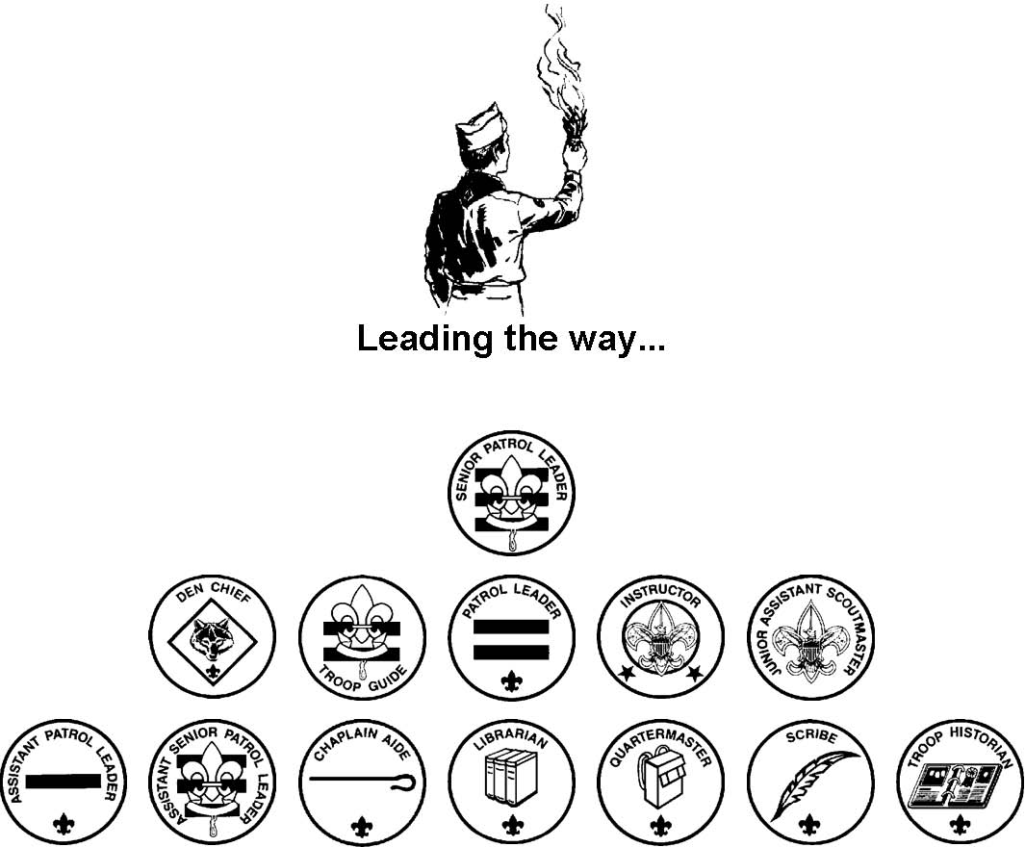

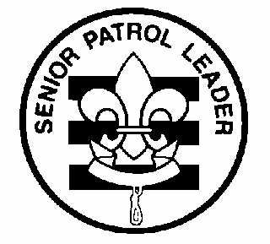
Troop 120
Leadership Positions
Senior Patrol Leader

General Information

Type: Elected by the members of the Troop

Term: 6 months minimum; May be longer depending on need

Reports to: Scoutmaster

Description: The Senior Patrol Leader is elected by the Scouts to represent them as the top junior leader in the troop.

Comments: The Senior Patrol Leader is the focal point of the troop. He needs to attend as close to all troop functions as possible. One of the major parts of the SPL's job is to appoint other troop leaders in conjunction with the Scoutmaster. He must choose leaders who are able, not just his friends or other popular Scouts.

Qualifications

Age: None

Rank: 1st Class or higher

Experience: Previous service as SPL, ASPL, PL, or APL

Attendance: Active attendance at meetings and outings

Performance Requirements

Training: You are expected to assist the Scoutmaster in leading Troop Junior Leader Training during your tenure, even if you have attended in the past.

Attendance: You are expected to attend 75% of all troop meetings, Patrol Leaders' Council meetings, outings, and service projects. If your attendance is low, or if you have three (3) unexcused absences in a row, you can be removed from office.

Effort: You are expected to give this job your best effort.

General Leadership Responsibilities

Uniform: Set the example by wearing your uniform correctly. This means that you will wear all of the parts of the troop uniform, shirttail tucked in, with all required badges in their correct locations.

Behavior: Set the example by living the Scout Oath and Law in your everyday life. Show Scout Spirit in everything you say and do.

Attendance: Set the example by being an active Scout. Be on-time for meetings and activities. You must call the Scoutmaster if you are not going to be at a meeting or if you suddenly have to miss an outing. You also need to make sure that the Assistant Senior Patrol Leader is ready to assume your responsibilities.

Specific Leadership Responsibilities
Runs all troop meetings, events, activities, and the annual program planning conference. Runs the Patrol Leader's Council meeting. Appoints other troop junior leaders with the advice and counsel of the Scoutmaster. Assigns duties and responsibilities to junior leaders. Assists the Scoutmaster with Junior Leader Training.

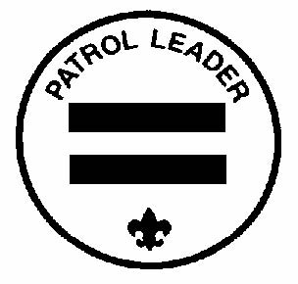
Troop 120
Leadership Positions
Patrol Leader

General Information

Type: Elected by members of the patrol Term: 6 months

Reports to: Senior Patrol Leader

Description: The Patrol Leader is the elected leader of his patrol. He represents his patrol on the Patrol Leader's Council.

Comments: The Patrol Leader may easily be the most important job in the troop. He has the closest contact with the patrol members and is in the perfect position to help and guide them. The Patrol Leaders, along with the Senior Patrol Leader and Assistant Senior Patrol Leader are the primary members of the Patrol Leaders' Council.

Qualifications

Age: None

Rank: None

Experience: None

Attendance: Active attendance at meetings and outings; SM and SPL will determine Scouts who meet this standard.

Performance Requirements

Training: You must attend Troop Junior Leader Training even if you have attended in the past.

Attendance: You are expected to attend 75% of all troop meetings, Patrol Leaders' Council meetings, outings, and service projects. If your attendance is low, or if you have three (3) unexcused absences in a row, you can be removed from office.

Effort: You are expected to give this job your best effort.

General Leadership Responsibilities

Uniform: Set the example by wearing your uniform correctly. This means that you will wear all of the parts of the troop uniform, shirttail tucked in, with all required badges in their correct locations.

Behavior: Set the example by living the Scout Oath and Law in your everyday life. Show Scout Spirit in everything you say and do.

Attendance: Set the example by being an active Scout. Be on-time for meetings and activities. You must call the Senior Patrol Leader or Scoutmaster if you are not going to be at a meeting or if you suddenly have to miss an outing. You also need to make sure that the Assistant Patrol Leader is ready to assume your responsibilities.

Specific Leadership Responsibilities
Appoints the Assistant Patrol Leader in consultation with the Scoutmaster. Represents the patrol on the Patrol Leader's Council Plans and steers patrol meetings Helps Scouts advance Acts as the chief recruiter of new Scouts Keeps patrol members informed Knows what his patrol members and other leaders can do.

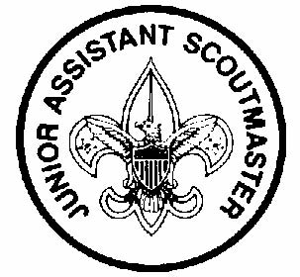
Troop 120
Leadership Positions
Junior Assistant Scoutmaster

GENERAL INFORMATION

Type: Appointed by the Scoutmaster

Term: 1 year

Reports to: Scoutmaster

Description: The Junior Assistant Scoutmaster serves in the capacity of an Assistant Scoutmaster except where legal age and maturity are required. He must be at least 16 years old and not yet 18. He's appointed by the Scoutmaster because of his leadership ability.

Comments In many cases the JASM has the same responsibilities as an Assistant Scoutmaster.

QUALIFICATIONS

Age: At least 16 years old

Rank: Eagle

Experience: Previous leadership positions

Attendance: Active attendance at meetings and outings.

PERFORMANCE REQUIREMENTS

Training: You are expected to assist with Troop Junior Leader Training during your tenure, even if you have attended in the past.

Attendance: You are expected to attend 50% of all troop meetings, outings, and service projects. If your attendance is low, or if you have three (3) unexcused absences in a row, you can be removed from office.

Effort: You are expected to give this job your best effort.

GENERAL LEADERSHIP RESPONSIBILITIES

Uniform: Set the example by wearing your uniform correctly. This means that you will wear all of the parts of the troop uniform, shirttail tucked in, with all required badges in their correct locations.

Behavior: Set the example by living the Scout Oath and Law in your everyday life. Show Scout Spirit in everything you say and do.

\Attendance: Set the example by being an active Scout. Be on-time for meetings and activities. You must call the Senior Patrol Leader or Scoutmaster if you are not going to be at a meeting or if you suddenly have to miss an outing. You also need to make sure that someone will assume your responsibilities.

SPECIFIC LEADERSHIP RESPONSIBILITIES
Functions as an Assistant Scoutmaster. Performs duties as assigned by the Scoutmaster.

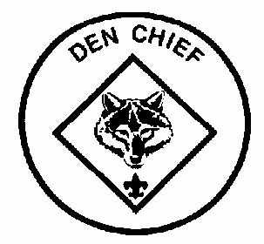
Troop 120
Leadership Positions
Den Chief

General Information

Type: Appointed by the SPL and Scoutmaster

Term: 1 year

Reports to: Scoutmaster and Den Leader

Description: The Den Chief works with the Cub Scouts, Webelos Scouts, and Den Leaders in the Cub Scout pack.

Comments: The Den Chief provides knowledge of games and Scout skills that many Den Leaders lack. The Den Chief is also a recruiter for the troop. This function is important because no troop can thrive without new members and most new members will come from Cub Scouting.

Qualifications

Age: 12 or older

Rank: First Class or higher

Experience: None

Attendance: Active attendance at meetings and outings

Performance Requirements

Training: You are expected to attend Troop Junior Leader Training.

Attendance: You are expected to attend 50% of all troop meetings, outings, and service projects. If your attendance is low, or if you have three (3) unexcused absences in a row, you can be removed from office. In terms of attendance with your den, you are expected to attend 90% of den meetings and pack functions. You must inform the Den Leader if you will be absent.

Effort: You are expected to give this job your best effort.

General Leadership Responsibilities

Uniform: Set the example by wearing your uniform correctly. This means that you will wear all of the parts of the troop uniform, shirttail tucked in, with all required badges in their correct locations.

Behavior: Set the example by living the Scout Oath and Law in your everyday life. Show Scout Spirit in everything you say and do.

Attendance: Set the example by being an active Scout. Be on-time for meetings and activities. You must call the Senior Patrol Leader or Scoutmaster if you are not going to be at a meeting or if you suddenly have to miss an outing. You also need to make sure that someone will assume your responsibilities.

Specific Leadership Responsibilities
Knows the purposes of Cub Scouting Helps Cub Scouts advance through Cub Scout ranks. Encourages Cub Scouts to join a Boy Scout troop upon graduation. Assists with activities in the den meetings. Is a friend to the boys in the den. Helps out at weekly den meetings and monthly pack meetings. Meets with adult members of the den, pack, and troop as necessary. Performs other duties assigned by SPL, ASPL, SM or ASM

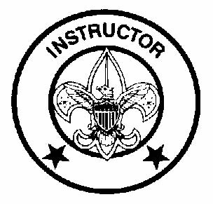
Troop 120
Leadership Positions
Instructor

General Information

Type: Appointed by the Scoutmaster in consultation with the SPL

Term: Min. 6 months

Reports to: Scoutmaster

Description: The Instructor teaches Scouting skills.

Comments: The Instructor will work closely with both the Troop Guides and with the Assistant Scoutmaster in charge of programs. The Instructor does not have to be an expert but must be able to teach the Scoutcraft skills needed for Tenderfoot, Second Class, and First Class ranks. Our Troop will have more than one instructor.

Qualifications

Age: 14 or older

Rank: Star or higher

Experience: None

Attendance: Active attendance at meetings and outings

Performance Requirements

Training: You are expected to assist with Troop Junior Leader Training.

Attendance: You are expected to attend 75% of all troop meetings, outings, and service projects. If your attendance is low, or if you have three (3) unexcused absences in a row, you can be removed from office.

Effort: You are expected to give this job your best effort.

General Leadership Responsibilities

Uniform: Set the example by wearing your uniform correctly. This means that you will wear all of the parts of the troop uniform, shirttail tucked in, with all required badges in their correct locations.

Behavior: Set the example by living the Scout Oath and Law in your everyday life. Show Scout Spirit in everything you say and do.

Attendance: Set the example by being an active Scout. Be on-time for meetings and activities. You must call the Senior Patrol Leader or Scoutmaster if you are not going to be at a meeting or if you suddenly have to miss an outing. You also need to make sure that someone will assume your responsibilities.

Specific Leadership Responsibilities
Teaches basic Scouting skills Assists on Boards of Review Assists as requested by Scoutmaster, Assistant Scoutmasters, SPL, or ASPL

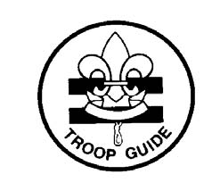
Troop 120
Leadership Positions
Troop Guide

General Information

Type: Appointed by the Scoutmaster in consultation with SPL

Term: min. 6 months

Reports to: Scoutmaster

Description: The Troop Guide works with the patrols and especially with new Scouts. He helps them feel comfortable and earn their First Class rank in their first year.

Comments: The first year as a Boy Scout is a critical time with new places, new people, new rules, and new activities. The Troop Guide is a friend to the new Scouts and makes first year fun and successful. This is an important position.

Qualifications

Age: 14 or older

Rank: Star or higher

Experience: None

Attendance: Active attendance at meetings and outings

Performance Requirements

Training: You are expected to assist with Troop Junior Leader Training.

Attendance: You are expected to attend 75% of all troop meetings, Patrol Leaders' Council meetings, outings, and service projects. If your attendance is low, or if you have three (3) unexcused absences in a row, you can be removed from office.

Effort: You are expected to give this job your best effort.

General Leadership Responsibilities

Uniform: Set the example by wearing your uniform correctly. This means that you will wear all of the parts of the troop uniform, shirttail tucked in, with all required badges in their correct locations.

Behavior: Set the example by living the Scout Oath and Law in your everyday life. Show Scout Spirit in everything you say and do.

Attendance: Set the example by being an active Scout. Be on-time for meetings and activities. You must call the Senior Patrol Leader or Scoutmaster if you are not going to be at a meeting or if you suddenly have to miss an outing. You also need to make sure that someone will assume your responsibilities.

Specific Leadership Responsibilities
Helps the patrol to which he is assigned Introduces newer Scouts to troop operations. Guides newer Scouts through early Scouting activities. Shields newer Scouts from harassment by older Scouts. Helps newer Scouts earn First Class in their first year. Teaches basic Scout skills. Coaches the patrol leader on his duties. Works with the patrol leader at Patrol Leaders' Council meetings. Attends Patrol Leaders' Council meetings Assists the Assistant Scout- masters and Instructors with training. Counsels individual Scouts on Scouting challenges. Assists on Boards of Review.

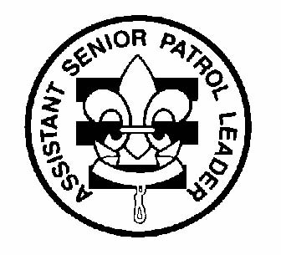
Troop 120
Leadership Positions
Assistant Senior Patrol Leader

General Information

Type: Appointed by the Senior Patrol Leader and Scoutmaster

Term: Min. 6 months

Reports to: Senior Patrol Leader

Description: The Assistant Senior Patrol Leader is the second highest ranking patrol leader in the troop. The Assistant Senior Patrol Leader acts as the Senior Patrol Leader in the absence of the SPL or when called upon. He also provides leadership to other junior leaders in the troop.

Comments: The most important part of the ASPL position is his work with the other junior leaders. The ASPL should be familiar with the other positions and stay current with the work being done.

Qualifications

Age: None

Rank: 1st Class or higher

Experience: None

Attendance: Active attendance at meetings and outings

Performance Requirements

Training: You must attend and assist with Troop Junior Leader Training even if you have attended in the past.

Attendance: You are expected to attend 75% of all troop meetings, Patrol Leaders' Council meetings, outings, and service projects. If your attendance is low, or if you have three (3) unexcused absences in a row, you can be removed from office.

Effort: You are expected to give this job your best effort.

General Leadership Responsibilities

Uniform: Set the example by wearing your uniform correctly. This means that you will wear all of the parts of the troop uniform, shirttail tucked in, with all required badges in their correct locations.

Behavior: Set the example by living the Scout Oath and Law in your everyday life. Show Scout Spirit in everything you say and do.

Attendance: Set the example by being an active Scout. Be on-time for meetings and activities. You must call the Senior Patrol Leader or Scoutmaster if you are not going to be at a meeting or if you suddenly have to miss an outing. You also need to make sure that someone will assume your responsibilities.

Specific Leadership Responsibilities
Helps the Senior Patrol Leader lead meetings and activities. Runs the troop in the absence of the Senior Patrol Leader. Helps train and supervise the Troop Scribe, Quartermaster, Instructor, Librarian, Historian, and Chaplin Aide. Serves as a member of the Patrol Leaders’ Council. Performs other duties assigned by SPL, SM or ASM.

Troop 120
Leadership Positions
Assistant Patrol Leader

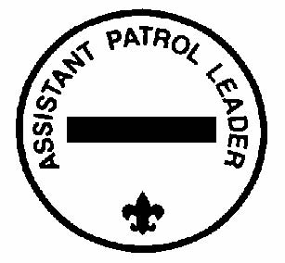
General Information

Type: Appointed by the Patrol Leader and Scoutmaster

Term: 6 months

Reports to: Patrol Leader

Description: The Assistant Patrol Leader is appointed by the Patrol Leader and leads the patrol in his absence. Comments: Substituting for the Patrol Leader is only part of the Assistant Patrol Leader's job. The APL actively helps run the patrol.

Qualifications

Age: None

Rank: None

Experience: None

Attendance: Active attendance at meetings and activities

Performance Requirements

Training: You must attend Troop Junior Leader Training even if you have attended in the past.

Attendance: You are expected to attend 75% of all troop meetings, Patrol Leaders' Council meetings, outings, and service projects. If your attendance is low, or if you have three (3) unexcused absences in a row, you can be removed from office.

Effort: You are expected to give this job your best effort.

General Leadership Responsibilities

Uniform: Set the example by wearing your uniform correctly. This means that you will wear all of the parts of the troop uniform, shirttail tucked in, with all required badges in their correct locations.

Behavior: Set the example by living the Scout Oath and Law in your everyday life. Show Scout Spirit in everything you say and do.

Attendance: Set the example by being an active Scout. Be on-time for meetings and activities. You must call the Senior Patrol Leader or Scoutmaster if you are not going to be at a meeting or if you suddenly have to miss an outing. You also need to make sure that someone will assume your responsibilities.

Specific Leadership Responsibilities
Helps the Patrol Leader plan and steer patrol meetings and activities. Helps the Patrol Leader keep patrol members informed. Helps the patrol get ready for all troop activities. Represents his patrol at Patrol Leader's Council meetings when the Patrol Leader cannot attend. Lends a hand controlling the patrol and building patrol spirit. Performs other duties assigned by SPL, ASPL, SM or ASM

Troop 120
Leadership Positions
Chaplain Aide

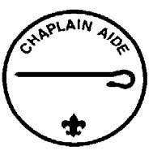
General Information

Type: Appointed by the Senior Patrol Leader and Scoutmaster

Term: Min. 6 months

Reports to: Assistant Senior Patrol Leader

Description: The Chaplain Aide works with the Troop Chaplain to meet the religious needs of Scouts in the troop. He also works to promote the religious awards program.

Comments: "Duty to God" is one of the core beliefs of Scouting. The Chaplain Aide helps everyone in the troop by preparing short religious observations for campouts and other functions. The Chaplain Aide does not always lead the observation himself and can have other troop members help.

Qualifications

Age: None

Rank: None

Experience: None

Attendance: Active attendance at meetings and outings

Performance Requirements

Training: You must attend the troop Junior Leader Training even if you have attended in the past.

Attendance: You are expected to attend 75% of all troop meetings, outings, and service projects. If your attendance is low, or if you have three (3) unexcused absences in a row, you can be removed from office.

Effort: You are expected to give this job your best effort.

General Leadership Responsibilities

Uniform: Set the example by wearing your uniform correctly. This means that you will wear all of the parts of the troop uniform, shirttail tucked in, with all required badges in their correct locations.

Behavior: Set the example by living the Scout Oath and Law in your everyday life. Show Scout Spirit in everything you say and do.

Attendance: Set the example by being an active Scout. Be on-time for meetings and activities. You must call the Senior Patrol Leader or Scoutmaster if you are not going to be at a meeting or if you suddenly have to miss an outing. You also need to make sure that someone will assume your responsibilities.

Specific Leadership Responsibilities
Assists the Troop Chaplain with religious services at troop activities. Tells Scouts about the religious emblem program for their faith. Makes sure religious holidays are considered during troop program planning. Helps plan for religious observance in troop activities. Perform other duties as requested by SPL, ASPL, SM or ASM

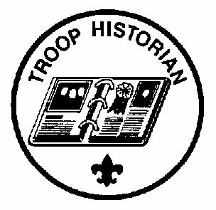
Troop 120
Leadership Positions
Troop Historian

General Information

Type: Appointed by the Senior Patrol Leader and Scoutmaster

Term: 6 months

Reports to: Assistant Senior Patrol Leader

Description: The Troop Historian keeps a historical record or scrapbook of troop activities.

Comments: The true value of a good Historian does not show up until years later. The Historian provides material for displays and presentations of current activities. In addition, the work of the Historian provides a link with the past.

Qualifications

Age: None

Rank: None

Experience: none, but interest in digital photography is helpful

Attendance: Active attendance at meetings and outings

Performance Requirements

Training: You must attend Troop Junior Leader Training even if you have attended in the past.

Attendance: You are expected to attend 75% of all troop meetings, outings, and service projects. If your attendance is low, or if you have three (3) unexcused absences in a row, you can be removed from office.

Effort: You are expected to give this job your best effort.

General Leadership Responsibilities

Uniform: Set the example by wearing your uniform correctly. This means that you will wear all of the parts of the troop uniform, shirttail tucked in, with all required badges in their correct locations.

Behavior: Set the example by living the Scout Oath and Law in your everyday life. Show Scout Spirit in everything you say and do.

Attendance: Set the example by being an active Scout. Be on-time for meetings and activities. You must call the Senior Patrol Leader or Scoutmaster if you are not going to be at a meeting or if you suddenly have to miss an outing. You also need to make sure that someone will assume your responsibilities.

Specific Leadership Responsibilities
Takes pictures of Troop meetings and activities. Gathers pictures and facts about past troop activities and keeps them in a historical file or scrapbook. Assists in putting together periodic electronic slide shows of Troop activities Takes care of troop trophies, ribbons, and souvenirs of troop activities. Keeps information about former members of the troop. Performs other duties assigned by SPL, ASPL, SM or ASM

Troop 120
Leadership Positions
Troop Librarian

General Information

Type: Appointed by the Senior Patrol Leader and Scoutmaster

Term: 6 months

Reports to: Assistant Senior Patrol Leader Description: The Troop Librarian takes care of troop literature.

Comments: The library contains books of historical value as well as current materials. All together, the library is a troop resource worth hundreds of dollars. The Librarian manages this resource for the troop.

Qualifications

Age: None

Rank: None

Experience: None

Attendance: Active attendance at meetings and outings

Performance Requirements

Training: You must attend the troop Junior Leader Training even if you have attended in the past.

Attendance: You are expected to attend 75% of all troop meetings, outings, and service projects. If your attendance is low, or if you have three (3) unexcused absences in a row, you can be removed from office.

Effort: You are expected to give this job your best effort.

General Leadership Responsibilities

Uniform: Set the example by wearing your uniform correctly. This means that you will wear all of the parts of the troop uniform, shirttail tucked in, with all required badges in their correct locations.

Behavior: Set the example by living the Scout Oath and Law in your everyday life. Show Scout Spirit in everything you say and do.

Attendance: Set the example by being an active Scout. Be on-time for meetings and activities. You must call the Senior Patrol Leader or Scoutmaster if you are not going to be at a meeting or if you suddenly have to miss an outing. You also need to make sure that someone will assume your responsibilities.

Specific Leadership Responsibilities
Sets up and takes care of a troop library Keeps records of books and pamphlets owned by the troop. Adds new or replacement items as needed. Keeps books and pamphlets available for borrowing. Keeps a system for checking books and pamphlets in and out. Follows up on late returns. Issues vouchers for purchase of used merit badge books. Performs other duties assigned by SPL, ASPL, SM or ASM

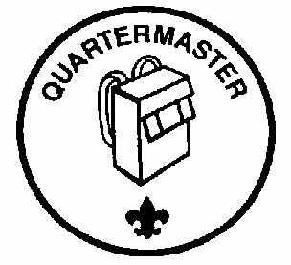
Troop 120
Leadership Positions
Troop Quartermaster

General Information

Type: Appointed by the Senior Patrol Leader and Scoutmaster

Term: 6 months

Reports to: Assistant Senior Patrol Leader

Description: The Troop Quartermaster keeps track of troop equipment and sees that it is in good working order. Comments: The Quartermaster does most of his work around campouts. There are times when the Quartermaster has to be available to check equipment in and out.

Qualifications

Age: none

Rank: none

Experience none

Attendance: Active attendance at meetings and outings

Performance Requirements

Training: You must attend the troop Junior Leader Training even if you have attended in the past.

Attendance: You are expected to attend 75% of all troop meetings, Patrol Leaders' Council meetings, outings, and service projects. If your attendance is low, or if you have three (3) unexcused absences in a row, you can be removed from office.

Effort: You are expected to give this job your best effort.

General Leadership Responsibilities

Uniform: Set the example by wearing your uniform correctly. This means that you will wear all of the parts of the troop uniform, shirttail tucked in, with all required badges in their correct locations.

Behavior: Set the example by living the Scout Oath and Law in your everyday life. Show Scout Spirit in everything you say and do.

Attendance: Set the example by being an active Scout. Be on-time for meetings and activities. You must call the Senior Patrol Leader or Scoutmaster if you are not going to be at a meeting or if you suddenly have to miss an outing. You also need to make sure that someone will assume your responsibilities.

Specific Leadership Responsibilities
Keeps records on patrol and troop equipment Makes sure equipment is in good working condition Issues equipment and makes sure it is returned in good condition Makes suggestions for new or replacement items Works with the Adult Quartermaster and others responsible for equipment Gets the US, troop, and patrol flags for meetings and ceremonies and puts them away afterwards. Performs other duties assigned by SPL, ASPL, SM or ASM

Troop 120
Leadership Positions
Troop Scribe

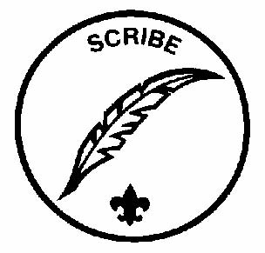
General Information

Type: Appointed by the Senior Patrol Leader and Scoutmaster

Term: 6 months

Reports to: Assistant Senior Patrol Leader

Description: The Scribe keeps the troop records. He records the activities of the Patrol Leaders' Council and keeps a record of attendance at troop meetings.

Comments: To be a good Scribe you need to attend nearly all troop and Patrol Leaders' Council meetings.

Qualifications

Age: None

Rank: None

Experience: None

Attendance: Active attendance at meetings and outings

Performance Requirements

Training: You must attend the troop Junior Leader Training even if you have attended in the past.

Attendance: You are expected to attend 75% of all troop meetings, Patrol Leaders' Council meetings, outings, and service projects. If your attendance is low, or if you have three (3) unexcused absences in a row, you can be removed from office.

Effort: You are expected to given this job your best effort.

General Leadership Responsibilities

Uniform: Set the example by wearing your uniform correctly. This means that you will wear all of the parts of the troop uniform, shirttail tucked in, with all required badges in their correct locations.

Behavior: Set the example by living the Scout Oath and Law in your everyday life. Show Scout Spirit in everything you say and do.

Attendance: Set the example by being an active Scout. Be on-time for meetings and activities. You must call the Senior Patrol Leader or Scoutmaster if you are not going to be at a meeting or if you suddenly have to miss an outing. You also need to make sure that someone will assume your responsibilities.

Specific Leadership Responsibilities
Attends and keeps a log of Patrol Leaders' Council meetings Assists in recording individual Scout attendance at meetings and outings Records individual Scout advancement progress at meetings and Scouts serving on Boards of Review for reporting to Scoutmaster Performs other duties assigned by SPL, ASPL, SM or ASM

